MANHOLE SPECIFICATION FORM
This form can be used for wetwells and pump chambers as well as manholes. Don’t forget that if using our pipe product, you do not need a manhole for a junction or a bend – these can be fabricated easily by Infrapipe. Simply answer the green for an early quote and then once the design is finalised confirming the orange questions provides your final drawing and quote. Easy.
CUSTOMER |  |  |  | FREIGHT TO
PHONE NUMBER |  | SCAN & EMAIL TO |  |  | sales@infrapipe.co.nz |  |  | FOR A QUOTE

Required for INDICATIVE QUOTE |  |  |  | Length  (if not stub to 500) | Benched  ? | Type of connection | Height  (DTI) | Angle to flow
Type | ID |  | OD
Inlet / Outlet |  |  |  |  | Y / N
Inlet / Outlet |  |  |  |  | Y / N
Inlet / Outlet |  |  |  |  | Y / N
Inlet / Outlet |  |  |  |  | Y / N
Inlet / Outlet |  |  |  |  | Y / N
Depth to lowest inlet/outlet |  |  |  |  | 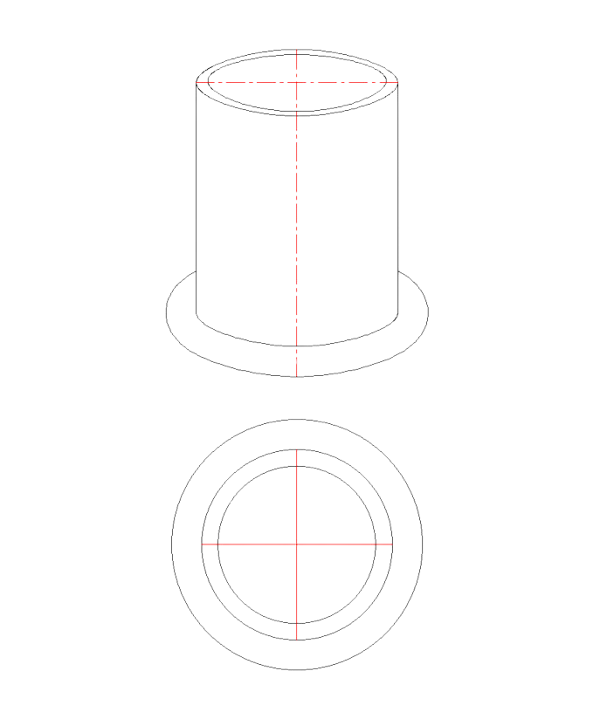
Diameter is minimum possible 1000+ unless specified here
Or if pump station, specify pump capacity here
Required for Final QUOTE

Soil Type (or send Geotech)

Max water Table (or send Geotech)

Gradients (or send drawings)

Is lid trafficable Y / N

Yellow interior for easiest inspection?

Manholes includes:
Lid, Ladder, Korum class D400 Ductile Iron hinged 600mm manhole cover & frame.
1–2 * WEEK LEAD TIME.

“IF YOU CAN DRAW IT, WE CAN MAKE IT”

  SCAN ME |  |  | CONTACT OUR TEAM
 |  |  |  | 09 869 3030 |  | sales@infrapipe.co.nz
 |  |  |  | 3 Averton Place East Tamaki, Auckland 2013 |  | infrapipe.co.nz
